Social Class

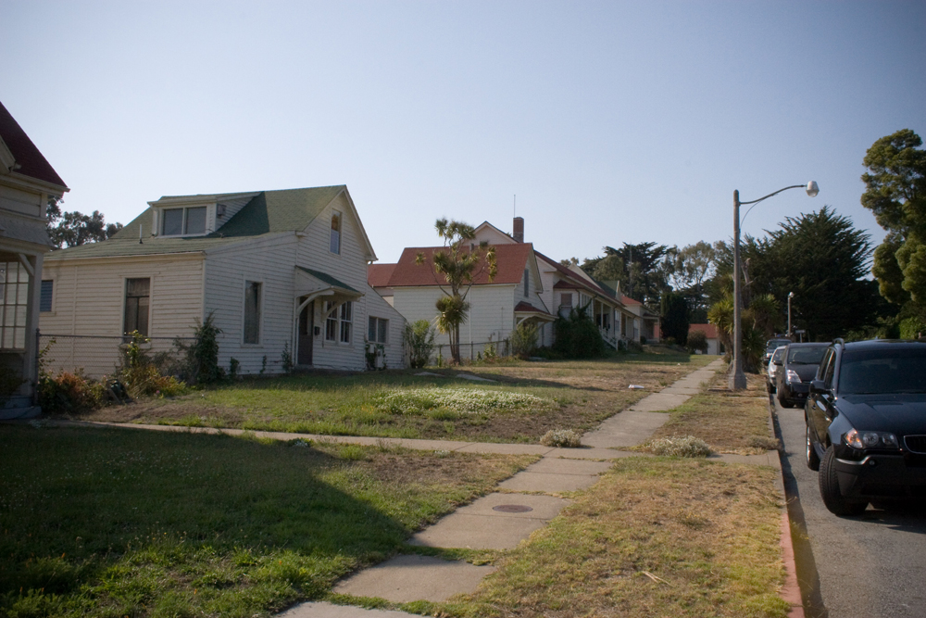

I chose this because it represents the social class differences in society. This image is advertisement of class stratification in our society between the rich and the poor are of residence. The people living in these houses indicates they are of same class having comparable levels education and revenue. In most societies in the world it is believe that the poor individuals don’t live next to rich individuals as shown on the above advertisement. The image shows the power and the privileges that the rich individuals in most cities enjoy as they live in prestigious estates like the one shown above. The houses are modern and the environment is conducive an indication that the people living here are rich.

